**OB Education**



**Contact:**

**Danna Wilson**

**970-463-6245**

**dwilson@schealth.org**

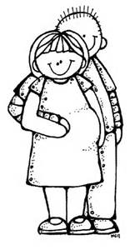

OB Class for First Time Parents

The OB class is a three night class for first time parents. It will cover breathing & relaxation techniques, the different stages of labor and basic infant care & safety. The first class will be at 6:30 pm in the Health Center Boardroom. Subsequent class times will be discussed and set during that first class. Classes are offered four times a year. Please choose a class that works best for you. If there are any questions, please feel free to contact Danna Wilson. First class dates are as follows:

October 5th, 2020

January 4th, 2021

April 5th, 2021

July 5th, 2021

October 4th, 2021

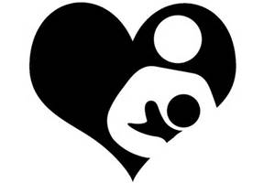

**Breastfeeding**

The Breastfeeding Class is open to all mothers. It will cover how breastfeeding works, feeding cues, feeding positions, proper latch, pumping, the working mother, and common problems. This class is also offered four times a year in correlation with the OB class and will be held on the fourth Monday of that month at 6:30 pm in the boardroom. Class dates are as follows:

October 26th, 2020

January 25th, 2021

April 26th, 2021

July 26th, 2021

October 25th, 2021